**Introduction to Databases**

Q1)Problem Statement: There can be multiple customers, who can place multiple orders on the site. Now a sales person can handle these orders will distribute into multiple sales persons (One order will be assign to one salesperson only). So a sales person can have multiple orders of multiple customers Create Database.

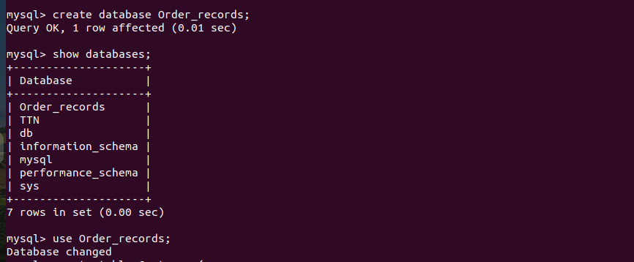  
Q2)Design Schema

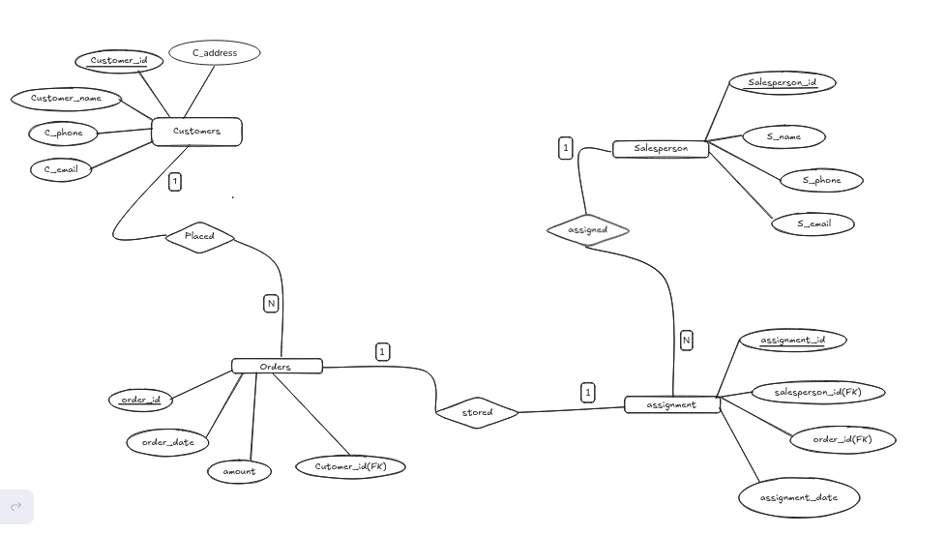

Q3)Create tables

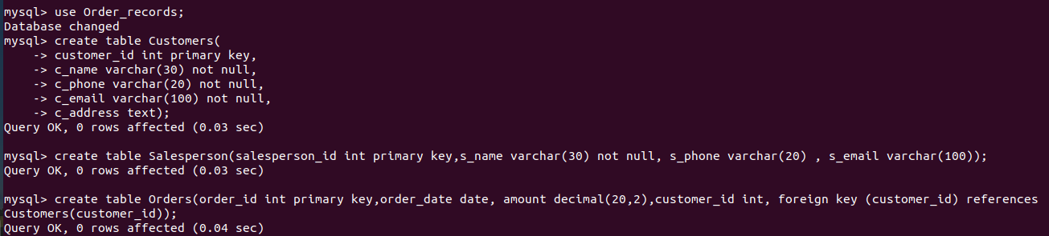

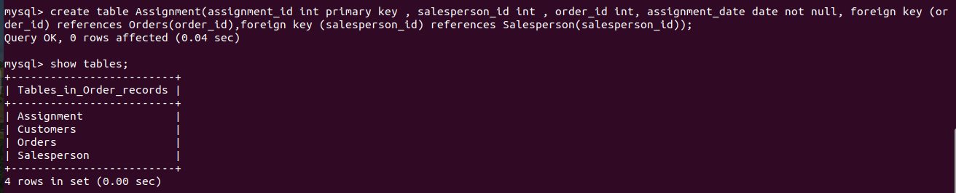  
Q4)Insert sample data

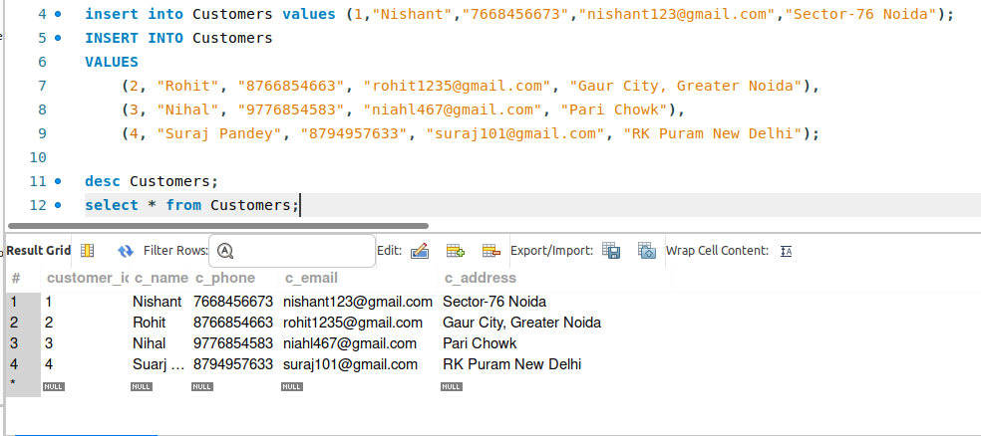

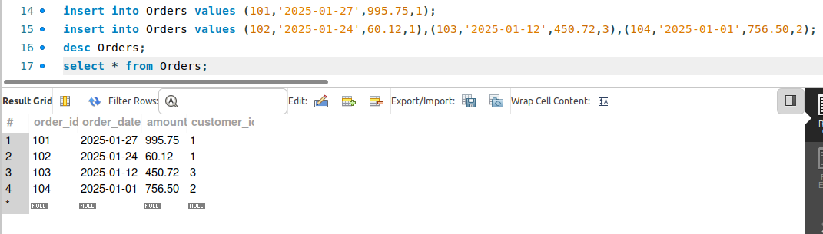

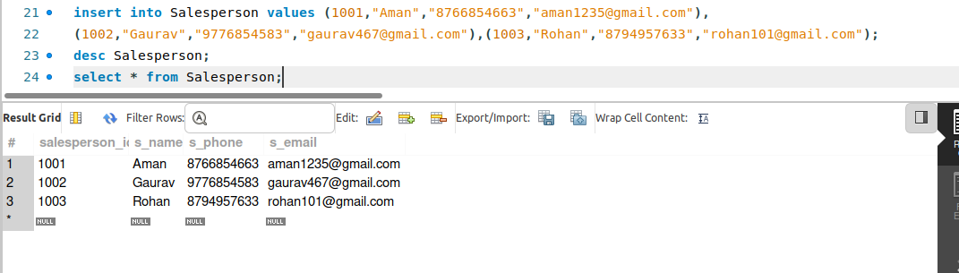

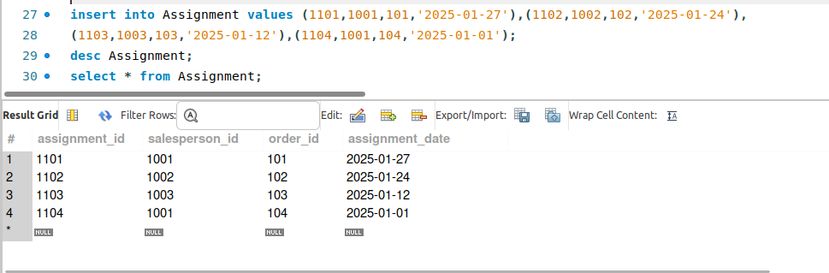  
Q5)Find the sales person have multiple orders.

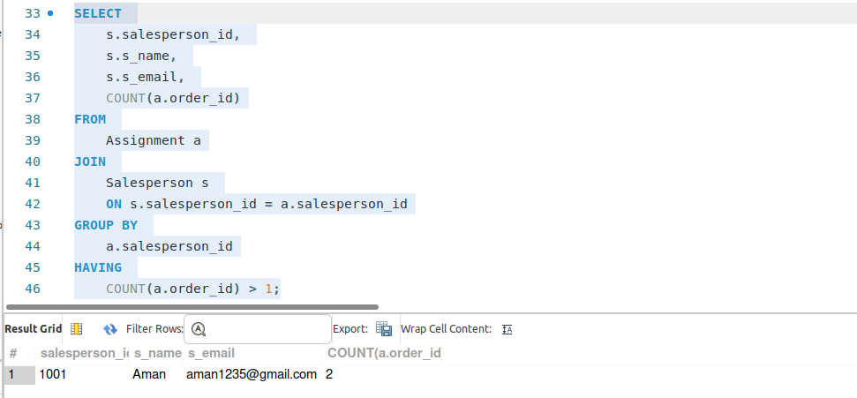

Q6)Find the all sales person details along with order details

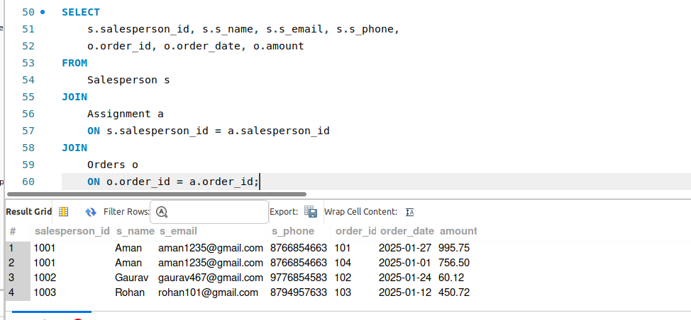  
Q7)Create index

  
Q8)How to show index on a table

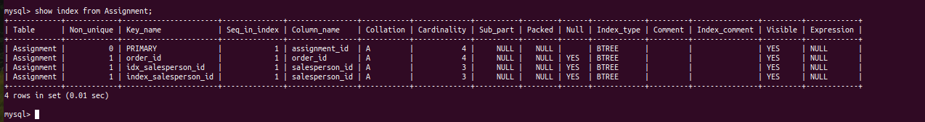  
Q9)Find the order number, sale person name, along with the customer to whom that order belongs to

